Selenium Grid

What is Selenium Grid?
Selenium Grid is a smart proxy server that makes it easy to run tests in parallel on multiple machines. This is done by routing commands to remote web browser instances, where one server acts as the hub. This hub routes test commands that are in JSON format to multiple registered Grid nodes.
Hub enables simultaneous execution of tests on multiple machines, managing different browsers centrally, instead of conducting different tests for each of them. Selenium Grid makes cross browser testing easy as a single test can be carried on multiple machines and browsers, all together, making it easy to analyze and compare the results.

Why use Selenium Grid?
Selenium Grid makes automation testing more efficient. Here’s why you set up Selenium Grid to perform tests:
- Parallel Testing: Selenium Grid lets you run multiple tests concurrently, reducing the test execution time. This is especially useful if you are handling large test suites, where running tests sequentially would consume a lot of time.
- Centralized Test Execution: The Selenium grid unifies the control of test execution via a single hub. It handles multiple nodes (machines/virtual machines) where the tests are performed, streamlining test management, particularly in larger teams.
- Cross-browser testing: It helps you ensure that the performance of your application is consistent across various browsers and browser combinations by enabling cross-browser testing.
- Scalability: Selenium Grid facilitates scalability by allowing you to add more nodes to the grid and enabling parallel tests.
- Open Source: Selenium grid is open-source and free. Additionally, the documentation is updated with every release, making it easier to install, configure, and use.

Architecture of Selenium Grid
The basic Selenium Architecture mainly consists of a hub-node model. The central hub manages multiple nodes.
- Hub: Hub is a server that accepts access requests from the WebDriver client, routing the JSON test commands to the remote drives on nodes. It takes instructions from the client and executes them remotely on the various nodes in parallel.
- Node: Node is a remote device that consists of a native OS and a remote WebDriver. It receives requests from the hub in the form of JSON test commands and executes them using WebDriver.
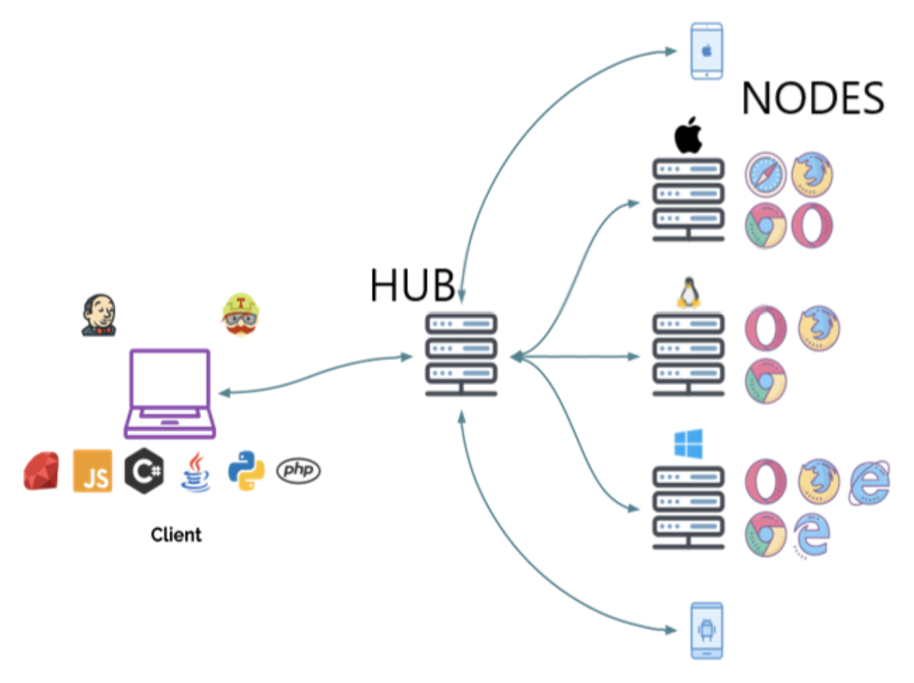

When should testers use Selenium Grid?
Testers should use Selenium Grid in the following circumstances:
- To run tests on multiple browsers and their versions, different devices, and operating systems
- To reduce the time that a test suite takes to complete execution
Selenium Grid improves the turnaround time of the test results. It is especially useful when the test suite is large and takes more time to run. It offers flexibility and ensures maximum test coverage within a limited time. Since the virtual infrastructure is in use, maintenance becomes easy.

Features of Selenium Grid
Here are the features of Selenium Grid 4:
1. Architecture Support: Selenium Grid 4 supports a few additional processes that enable deployment in various ways. They are:
- Router
- Distributor
- Session Map
- New Session Queue
- Node
- Event Bus
2. Diverse Grid Roles: Selenium Grid can be configured via:
- Standalone Mode
- Classical Grid (Hub and Node)
- Fully Distributed (Event Bus, New Session Queue, Session Map, Distributor, Router and Node)
3. Docker Support: Selenium Grid offers built-in support for docker that runs on port 2375.
4. Observability: This feature helps understand and debug the internal process since it works in a fully distributed state. Traces, metrics, and logs are the three main components that provide in-depth insights.
5. GraphQL Query Support: Being the query language for APIs, graphQL is used to query and fetch the data that the user needs. Since Selenium Grid supports, GraphQL, a simple query can bring details like current session count, node and grid updates, max session count etc.
6. Node Customization: This lets you customize and update nodes as per the test execution requirements. For example, configuring a node to perform tests on a specific browser version that the test requires.
7. External Data Store: With Selenium Grid, you can save information on the currently running sessions into an external data store.

Components of Selenium Grid 4
Here are the 6 main components of Selenium Grid 4:
- Router: It serves as the gateway for the grid and receives external requests. Then, it guides them to the right component to be handled.
- Distributor: Distributor manages node registration and capabilities along with assigning new session requests to the right nodes from the Session Queue. It then updates the Grid’s model with Node status.
- Session Map: The link between Session IDs and Nodes are stored here.
- Session Queue: Incoming session requests are held in a FIFO (first in, first out) manner.
- Nodes: Facilitates test execution in a distributed network. Nodes with specific configurations must register with the Distributor to receive the right requests.
- Event Bus: Enables internal communication between the grid components using messages, thus avoiding direct HTTP calls.
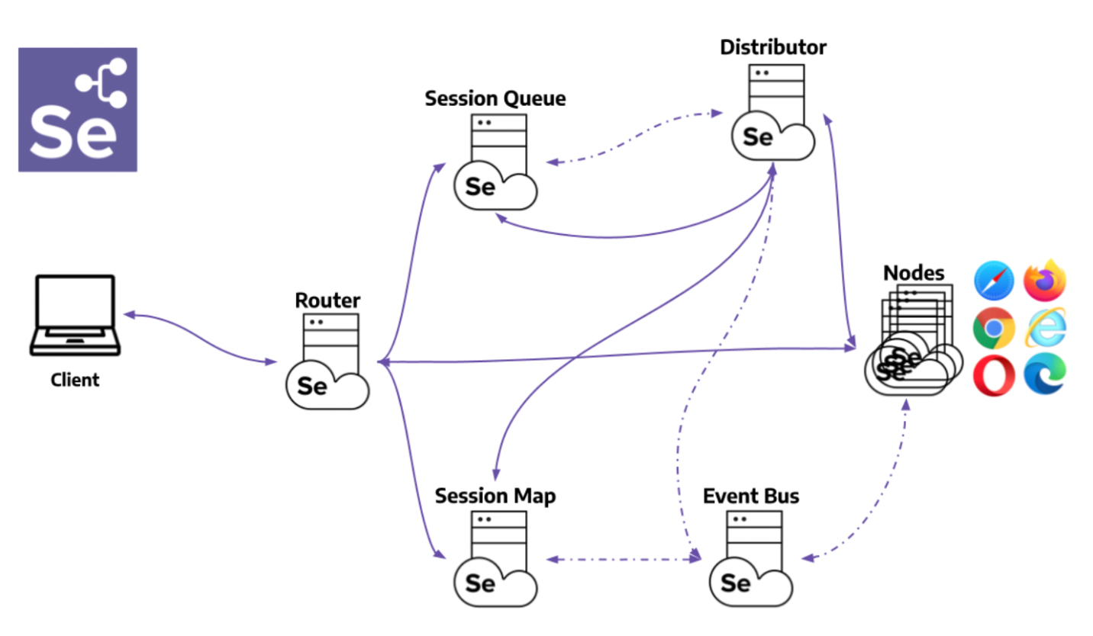

How to setup Selenium Grid for Cross Browser Testing

Step 1: Installation
Before getting started, download the Selenium Server Standalone package. This package is a jar file, which includes the Hub, WebDriver, and legacy RC that is needed to run the Grid. To get started with Selenium Grid, it is essential to have Java already installed, and set up the environment variables.

Step 2: Start Hub
Hub is the central point in the Selenium Grid that routes the JSON test commands to the nodes. It receives test requests from the client and routes them to the required nodes. To set up the Selenium Hub, open the command prompt, and navigate to the directory where the Selenium Server Standalone jar file is stored (downloaded in Step 1) using the following command.
java -jar selenium-server-standalone-<version>.jar -role hub
This will start the Hub automatically using port 4444 by default. Testers can change the default port by adding an optional parameter port, using
-host <IP | hostname>
while running the command. Testers need not specify the hostname as it can be automatically determined unless someone is using an exotic network configuration or networking with VPN. In that case, specifying the host becomes necessary.
To view the status of the hub, open a browser window and navigate to https://localhost:4444/grid/console

Step 3: Start Nodes
Whether testers are looking to running a grid with new WebDriver functionality or with the Selenium 1 RC functionality or running both of them simultaneously, testers have to use the same Selenium Server Standalone jar file, to start the nodes. To start nodes open the command prompt and navigate to the directory, where the Selenium Server Standalone jar file is stored.
Type the following command
java -jar selenium-server-standalone-<version>.jar -role node -hub https://localhost:4444/grid/register
When -role option that is provided is not specified, and it is not the hub, the default port is 5555. So, it is important to define the -role to be a node in this case.

Step 4: Configure Nodes
When testers start the nodes, by default, it allows 11 browsers, i.e., 5 Firefox, 5 Chrome, and 1 Internet Explorer for concurrent use. It also allows testers to conduct a maximum of 5 concurrent tests by default.
Testers can change this and other browser settings, by configuring nodes. This can be done by passing parameters to each of the -browser switches that represent a node, based on the parameters.
As soon as the -browser parameter is used, the default browser settings shall be ignored and only the parameters that are specified in the command line shall be used.
Let us understand this with an example to set 4 Firefox version 4 nodes on a Windows machine.
-browser browserName=firefox,version=4,maxInstances=4,platform=WINDOWS
In a case where the machine has multiple versions of Firefox, map the location of each binary to the compatible version on the same machine.
Let us understand this by the following example where there are two versions of Firefox, namely 3.6 and 4 on the same Windows machine that have to be used at 5 and 4 instances respectively.
-browser browserName=firefox,version=3.6,firefox_binary=/home/myhomedir/firefox36/firefox,maxInstances=5,platform=WINDOWS -browser browserName=firefox,version=4,firefox_binary=/home/myhomedir/firefox4/firefox,maxInstances=4,platform=WINDOWS
This way, testers can configure the nodes as per their cross browser testing requirements, using desired combination of browsers, their versions, and operating systems.

Step 5: Using Selenium Grid to run tests
Once the Selenium Grid setup is done by following the above 4 steps, testers can access the grid to run tests. If Selenium 1 RC nodes are being used, testers can use DefaultSelenium object and pass the same in the hub formation using the following command.
Selenium selenium = new DefaultSelenium(“localhost”, 4444, “*firefox”, “https://www.browserstack.com”);
If testers are using Remote WebDriver nodes, they must the RemoteWebDriver and DesiredCapabilities objects to define the browser, version, and platform. For this, create the target browser capabilities to run the test on:
DesiredCapabilities capability = DesiredCapabilities.firefox();
Once created, pass this set of browser capabilities into the RemoteWebDriver object:
WebDriver driver = new RemoteWebDriver(new URL("https://localhost:4444/wd/hub"), capability);
Once this is done, the hub would assign the test to a matching node, if all the requested capabilities meet. To request any specific capabilities on the grid, specify them before passing them to the WebDriver object in the following pattern:
capability.setBrowserName();
capability.setPlatform();
capability.setVersion()
capability.setCapability(,);
If these capabilities do not exist on the Grid, the code returns no match and thus the test fails to run.
Let us understand this using an example, considering a node is registered with the setting:
-browser browserName=firefox,version=4,maxInstances=4,platform=WINDOWS
Then, it is a match with the following set of capabilities defined for the test:
capability.setBrowserName(“firefox” );
capability.setPlatform(“WINDOWS”);
capability.setVersion(“4”);
It would also match with the following set of capabilities defined for the test”
capability.setBrowserName(“firefox” );
capability.setVersion(“4”);
Note that the capabilities which are not specified for the test would be ignored, such as in the above example where the platform parameter is not specified and it gets a match.

